Manual Website Audit
From vision impaired persons perspective what areas need to be considered when doing a Manual Website Auditing?

There are many automatic tools available to perform website accessibility audit. To ensure the website conforms to the Web Content Accessibility Guidelines (WCAG). The automatic tools provide an extensive audit, however these tools cannot fully simulate how different users navigate through a website. It is therefore important that a manual auditing is also carried out to ensure accessibility.

The following are some practical checks to ensure users can access the websites.

Page Titles 2
Page Content 2
Headings 2
Menu Structure 2
Images 2
Captions 2
Challenges on webpages 2
Meaningful Links 3
Collecting Information on a Website 3
General Access 5

Page Titles
Check that each Page Title has meaningful name that user can easily identify the site.

Page Content
Check that the website pages provide easy access to the main content by testing either:
- a link at the top of webpage <skip to main content>
- for screen reader users typing H for heading will provide them with a content list window

Headings
Headings should be meaningful and well structured. For example:
- Heading 1 should be the main heading – eg. page subject
- Heading 2 is the next level heading – eg. services provided.
- Heading 3 should be subheading from heading 2 – eg. key areas of each service
Heading structure sounds obvious however websites and documents do not always use this approach consistently and therefore confusing and time consuming for vision impaired users.

Menu Structure
It is important to plan and test good menu structure. Areas to consider include:
- Sub menus can be identified
- Users can work with Sub menus to navigate into different areas of the website
- More importantly the sub menus need to be set up correctly to return user to the original menu level.
- In JAWS use link list <ins> F7 or down arrow key

Images
- Alternate Text (Alt Text) exists for all images (with some exception such as logo) and the description therefore needs to be meaningful.
- Alternate Text (Alt Text) does not appear on the page as text, only read out by screen reading software.
- The Mentoring Program has developed an Alternate Text (Alt Text) Checklist which is available to assist with this process.

Captions
- Captions appear below Graphic/frame/picture (except logo)
- Captions are necessary for sighted user and users with a vision impairment to know what the graphic/frame/picture is and connection to rest of page content.

Challenges on webpages
- Ensure the page setup does not take user to a different focus point without user request.
- Try to avoid flashing images or text. When using JAWS, flashing features might look good for sighted users however for vision impaired users it creates significant challenges. For example - The flashing feature will continually redirect JAWS screen reader back to the area of the flashing. The JAWS user can move on but when the flashing changes the focus is continually redirected back to information that has already been read. To continue accessing information on the website the user then needs to find what they were reading and the issue with flashing and redirection continues. Therefore people with a vision impairment struggle and give up trying to get information from this type of webpage design.

Meaningful Links
- Ensure all links are meaningful
- Don’t just use ‘click’ or ‘read more’ without adding meaningful information.
- For example, ‘read more’ should be ‘read more about the subject or information’ provided. It could be:
  - Read more about the historical building
  - Read more about the services garbage management offers
  - Read more about the events happening soon
- Location of link is also important. Ensure all information relating to the link is above the link and not below the link. For example, the sentence ‘xxx historical building was built in 1802 and has been restored by …’ Should be before ‘Read more about historical building’ or ‘Click for more historical building information’.
- Do not locate link before the information provided. If user is reading down the page, they need the information first before pressing the link. If the information is after the link, users may miss important information related to the link.
- Sighted users can see the information before clicking the link however the set up sequence of information and links needs to be considered for users with a vision impairment.
- The reason for providing a bit more detail with link instruction and putting link in the correct position is because there are pages with several link options and the user could select the wrong ‘click’ or ‘read more’ button and end up lost on a page they did not need.
- As mentioned earlier some websites have poor menu structure and so getting back to the original page is not always straightforward for a vision impaired user no matter how skilled they might be.

Collecting Information on a Website
When it comes to pages where users are required to input information the set-up works by having all descriptions and information relating to the form located above the input fields.

Including information and details about eligibility, names, fees above the forms that need to be filled is extremely helpful to all users. The following example has headings above and headings below the input fields. Ideally the following example will have both First Name and Last Name above each input box.

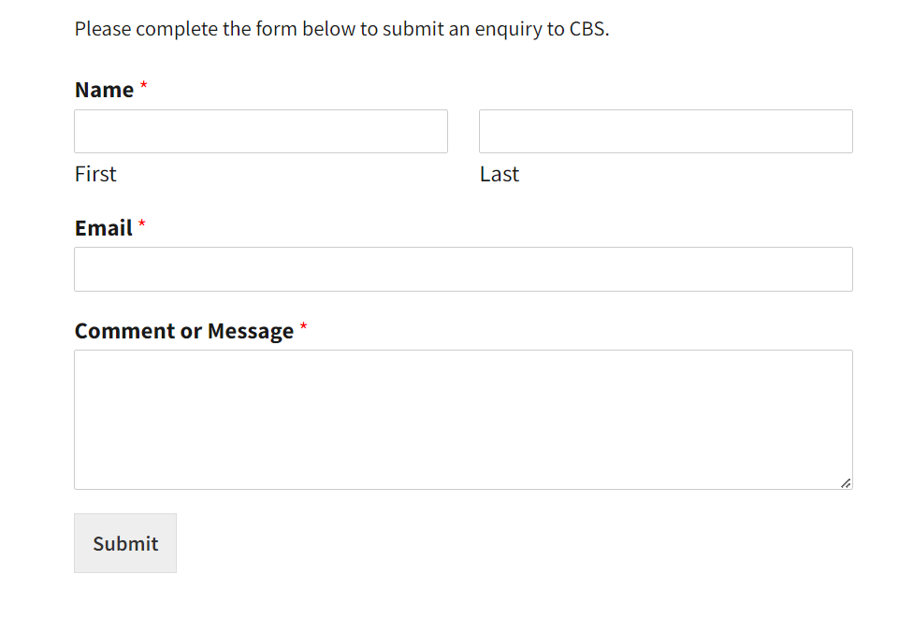
It is helpful to provide details required for on-line form before the form need to be outline what information is required. If a user doesn’t know the information required, such as cost, they will waste time entering details and decide not to join based costs being too high or not meeting the membership criteria.

Include an introduction when offering the opportunity to join a group or organisation. Providing a summary of all the relevant information about who can join, membership types, fees (yearly or one-off fees), and even method of payment is helpful in stopping a back and forth in the application process. The user then knows what is required before they start entering the information and can be fully prepared before starting to enter details.

An example – This form will ask for your name, contact information, what type of information you would like to receive and at the end it will ask for credit card details in order to pay the $20 membership fee which is tax deductable.

Be clear with labelling information needed for each input field. The following examples need to go above the input field/box/feature. If under or after the input field/box/feature it is confusing for the user with a vision impairment.

What system is set up to collect names?
- Full name in one input field
- First name in one input field followed by Surname/Last in another one input field

When collecting Date of Birth what format is set up for example (dd/mm/yyyy)?

Think about how you are capturing information from users:
- Input form/ field/box/features submit process that captures information automatically presents challenges.
- A submit button after all field/box/features are complete, or save button through the process provide full user control over when and what personal information is captured.

All mandatory fields must be indicated in the summary. The common feature of an asterisk can be confusing.

Error checking needs to include and provide more meaningful error message outlining which input field/box/feature needs to be reviewed. A general no complete message at the end of the page can be confusing. This again would be helpful for both sighted and vision impaired users. It is often not clear which area needs attention.

General Access
- Developers need to check with JAWS users to test if JAWS (Jobs Access With Speech) is able to access all parts of the website using keyboard.
- All information on the webpage must be able to access via the keyboard.
- All navigation of the website can be done without the use of a mouse.
- It is necessary to have good contrast (4.5 to 1) for sighted user. An automatic tool can pick this up.
- Manual audit, the Contrast on the screen should allow sighted or low vision users to see information clearly.
- Content information should allow user to understand information easily.
- Avoid Acronyms, as screen reader pronounce the Acronyms by just reading letters or an unrelated word which often don’t make sense. If Acronym is used, this must be explain prior to first use and regular throughout the webpages.
- Manually use screen reader to listen to the entire webpage. This assists in checking for any spelling mistakes or missing words, the user would notice while listening to unusual pronunciation or sentence that don’t make sense.
- Having someone with a vision impairment and magnifying and/or screen reader software skills to test a new site is extremely helpful. The developer might miss potential issues while another tester, especially someone with lived experience of a vision impairment, might pick up an area that doesn’t work well or where the new design could be confusing.

