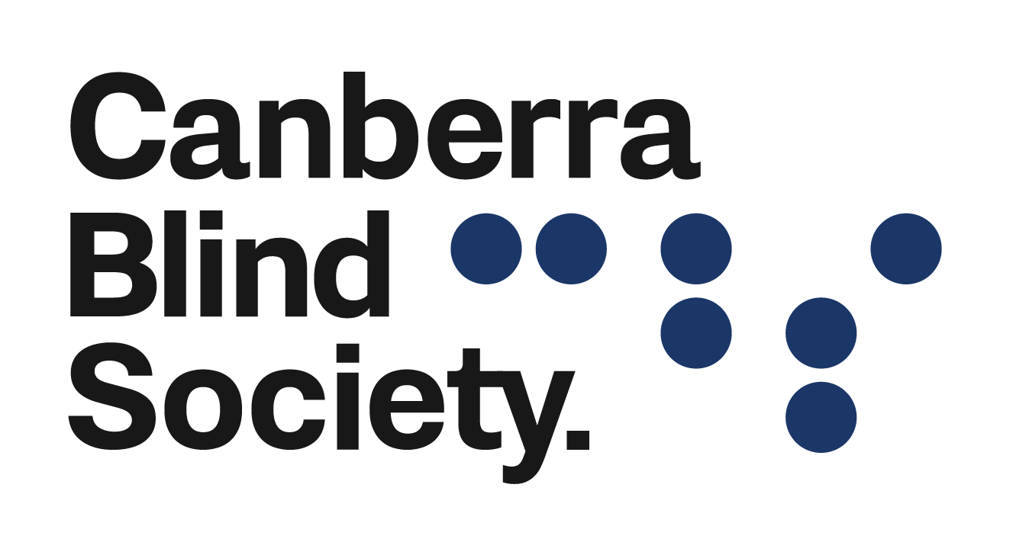

May 2022
Announcements

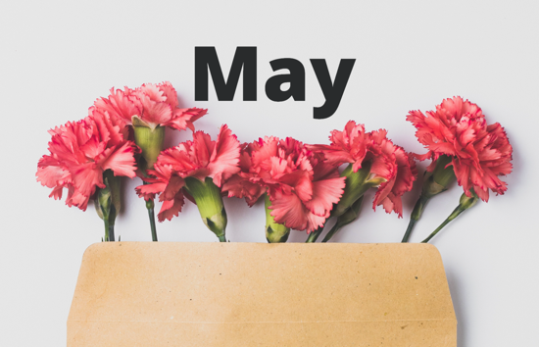
Celebrating National Volunteering Week
16th May - 22nd May
EFLC-CBS members are invited to an exhibition on Friday, May 6th at 1pm at M16 Artspace, 21 Blaxland Crescent, Canberra. Naomi Oliver the artist, will be there to discuss her work and talk about what triggered the process of creating Wheel of Fortune.
Wheel of Fortune, will stand 1800cm high x 85.2cm diameter, and be comprised of 20 oil paintings that explore fate, chance, displacement and aspirational dreams. The glitch as a metaphor for life in limbo, unpredictability and technology gone awry will be an underlying theme.
Spinning the wheel triggers flashing coloured lights and each painting is accompanied by a different soundscape, once the pointer comes to rest upon it.
Call Debra at the office on 6247 4580 and put your name on the list, or email events@canberrablindsociety.org.au
If you require transport you will need to contact Volunteers@canberrablindsociety.org.au

Glitch - The Exhibition
EFLC-CBS members are invited to an exhibition on Friday, May 6th at 1pm at M16 Artspace, 21 Blaxland Crescent, Canberra. Naomi Oliver the artist, will be there to discuss her work and talk about what triggered the process of creating Wheel of Fortune.
Wheel of Fortune, will stand 1800cm high x 85.2cm diameter, and be comprised of 20 oil paintings that explore fate, chance, displacement and aspirational dreams. The glitch as a metaphor for life in limbo, unpredictability and technology gone awry will be an underlying theme.
Spinning the wheel triggers flashing coloured lights and each painting is accompanied by a different soundscape, once the pointer comes to rest upon it.
Call Debra at the office on 6247 4580 and put your name on the list, or email events@canberrablindsociety.org.au
If you require transport you will need to contact Volunteers@canberrablindsociety.org.au

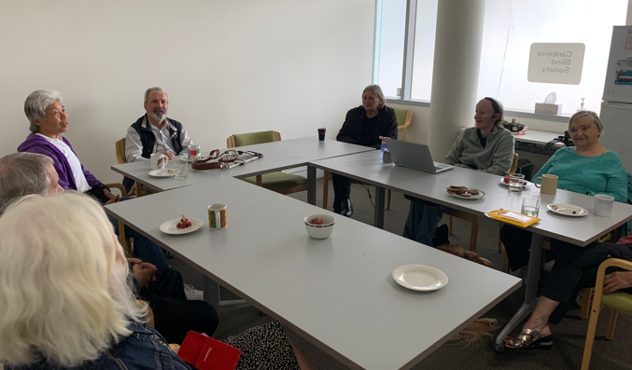
Audio Book Group
We meet again on Wednesday 4th May to chat over coffee and tea, and to discuss our Australian Colonial Historical fiction book, ‘Before you knew my name’ by Jacqueline Bulbitz.
Vacancies exist, so contact EFLC-CBS for joining details. Our members are privileged with a personalised tour of the National Gallery exhibitions each first Sunday of the month.

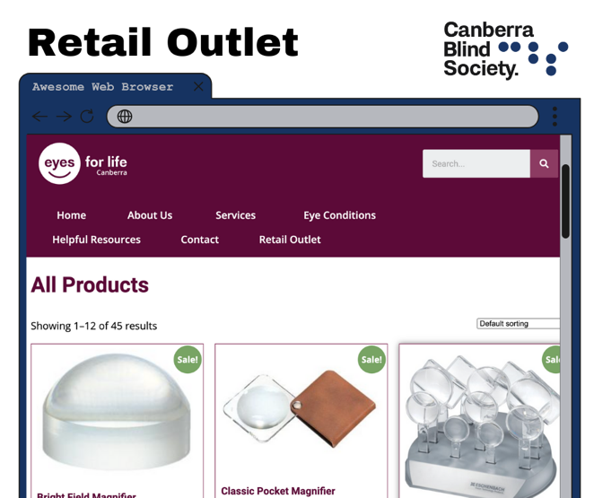

Eyes For Life Retail Outlet
Eyes For Life Canberra has a retail outlet! We sell all things low vision. Head over to https://eflc.org.au/retail-outlet/ to check it out!

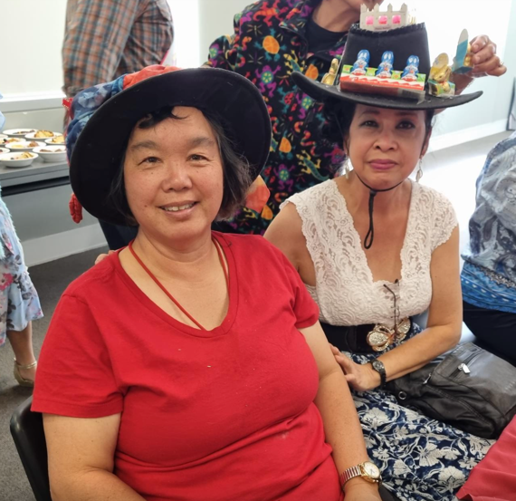
Easter Lunch
Thursday 14 April 2022.
The Easter lunch held on Thursday 14 April was well attended. It was a good mix of clients with the banquet style table seating families and children of some of our members. The feedback I received was positive about the food, but also how wonderful it was to be with old friends again.
The Easter Hat prizes judged by Claire went to Lien, Syeria, Natalie, Yang and Cathy for their creative and unique hats.
Many thanks go to volunteers on the day, Ian and Jenny, Travis, Paul, Darren and Brittany for their help to set up the dinning room, food preparation and providing transport to our members who joined the lunch celebration on the day. A special mention to Mohit for providing all the food items for a scrumptious Easter lunch.

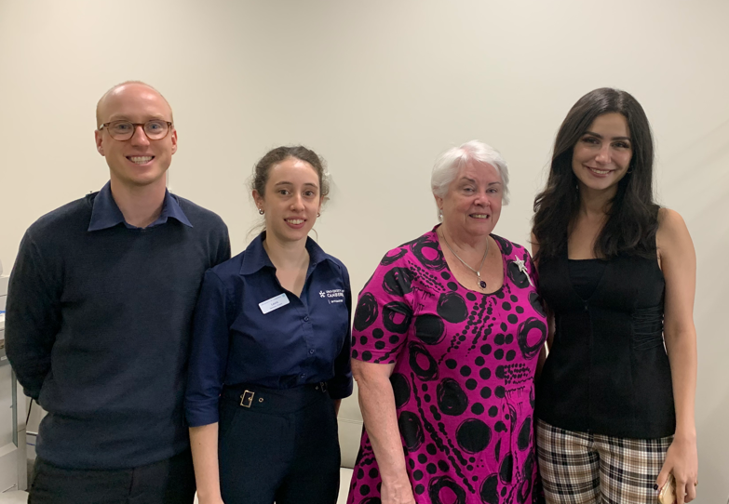

Optometry Students
Recently the University of Canberra Optometry students came to visit Canberra Blind Society, they talked with one of our vision impaired clients and our President Heather Fitzpatrick regarding the different experiences they have had with optometrists over their time.
The two students and teacher asked a range of questions and practiced their skills at the Canberra Blind Society offices.

Check our website and socials for all up to date information about what's happening at
Canberra Blind Society.

To give any feedback on this new platform or unsubscribe please email vco@canberrablindsociety.org.au

