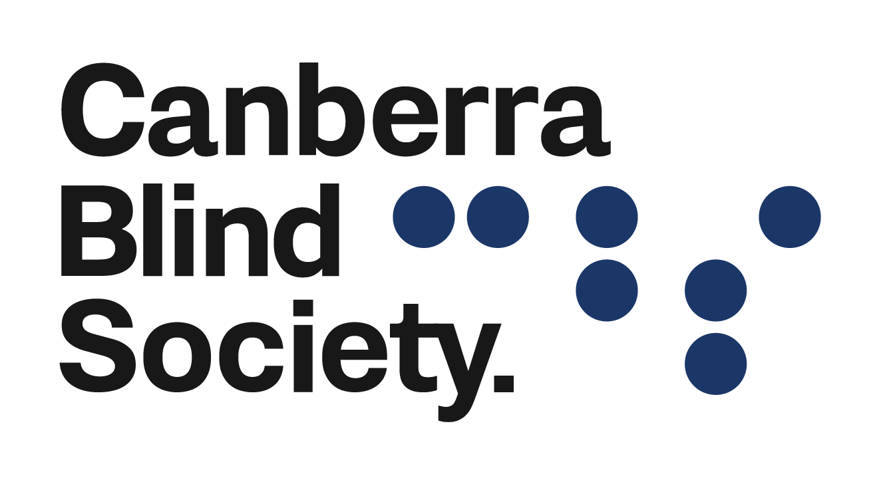

July 2022
Announcements

A reminder to all members, clients, volunteers and staff. If you are not well then please do not come into the office but stay at home. A sniffle may be a cold or the start of Influenza or even COVID-19 as they all share common signs and symptoms to a certain extent. Without the explicit testing via PCR then you only be guessing which of the three you had contracted. As we have several people who have underlying medical conditions, then we would please ask you consider their wellbeing and so avoid coming into the office if you are unwell and experiencing symptoms. All the staff as per ACT Health guidelines are wearing a mask when clients enter our premises.

NDIS Clients

Dear All
As of August 1st 2022, Canberra Blind Society (CBS) will be introducing charges for NDIS clients who attend our programs. The non NDIS clients will not be charged, however we would certainly accept a donation of some amount. As we move further into the NDIS era, then having funds to continue our programs is paramount to CBS being able to afford rent of our premises as well as administration and utility costs that continue to increase on a yearly basis.
Any funds generated will go back into CBS to support those that are not eligible for NDIS funding. Please note, the “lead” person of each group will not be charged as we feel their contribution of their time as a volunteer is sufficient in terms of payment. An invoice will be drawn up after each program concludes and sent to each of the NDIS clients who are either Self-Managed or to their Plan Manager with the costings following NDIS guidelines as well as dividing the overall costs between the number of NDIS clients who are participating in each program.
As an example if a program has 8 NDIS clients one week, then the hourly rate will be divided by 8 to raise the invoice. However, in the next session then there may only be 4 NDIS clients and hence the total will be divided by 4 and so that program will cost more than the previous session due to less people being present on that day.
Staff will record names of NDIS clients are who present or may turn up late to share the expense between as many people as possible.
If you have any concerns, then please direct them through to Debra or myself.
Kind Regards Glenn

Canberra Wine Tour
EFLC-CBS members are invited to a Canberra Wine Tour. There are only 20 seats available so if you would like to join us on Saturday 30 July 2022 to experience a wine tasting followed by a lunch and are over the age of 18 then please send your Expression of Interest to Debra at events@canberrablindsociety.org.au. Debra is available to take your Expression of Interest over the phone (62474580) for those who do not use emails. In less than 25 words express why you would like to indulge in the treats of the Murrumbateman wine country.
A bus pick up from 20 Genge Street, Griffin Centre will be available at 9.30 am for this half day winery tour. You will enjoy the tour in comfortable air-conditioned transportation, visit 3 Cellar Doors, plus lunch at Murrumbateman Winery.
The bus will return to 20 Genge Street, Griffin Centre at approximately 2:30pm. For further information call Debra at the office on 6247 4580.
NSW COVID restrictions apply
Restaurants, cafes, hospitality venues and nightclubs in NSW are open.
Anyone can visit a restaurant, cafe, hospitality venue or nightclub.
- You are not required to be fully vaccinated or carry vaccination evidence
- COVID-19 Safe Check-in is not required at hospitality venues
- COVID-19 Safe Check-in is still required at nightclubs
- Face masks are not required.
NSW Health strongly advises that patrons consider being seated while drinking.
From 18 February 2022, there are no restrictions for singing and dancing.
Drinking indoors and outdoors may be seated or standing.
Examples of hospitality premises include casinos, restaurants, cafes, function centres, food courts, take away food and drink premises, kiosks, micro-breweries or small distilleries, cellar doors, pubs, registered clubs and small bars.

The Ten Tenors – Canberra Theatre
EFLC-CBS members are invited to attend a performance by the Ten Tenors at the Canberra Theatre on Saturday 6 August 2022 at 2 pm. There are only 16 tickets available so if you would like to join us on Saturday for the matinee performance, please send your Expression of Interest to Debra at events@canberrablindsociety.org.au. Debra is available to take your Expression of Interest over the phone (62474580) for those who do not use emails. In less than 25 words express why you would like to attend this fabulous performance by the Ten Tenors.
For further information call Debra at the office on 6247 4580 or email events@canberrablindsociety.org.au
If you require transport you will need to contact Volunteers@canberrablindsociety.org.au

Audio Book Group
Audio Book group will meet on Wednesday 5th July for a family saga and tale of immigrant adaption to Australia ranging from Western Australia to Mossy Point, “The Islands” by Emily Brugman.
There is a simple advantage to being an audiobook reader, we never read alone, it is always a shared pleasure. But even better than reading an audiobook is getting together with others and to share the pleasure still further. Why not join us!

Check our website and socials for all up to date information about what's happening at
Canberra Blind Society.

To give any feedback on this new platform or unsubscribe please email vco@canberrablindsociety.org.au

