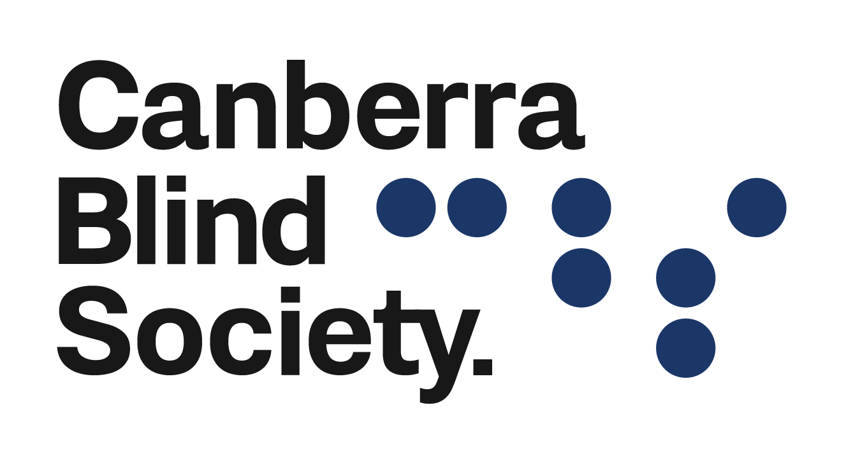

October 2022
Announcements

Canberra Symphony orchestra
On the 15th of September, Canberra Blind Society clients were given tickets by Helping Hands to attend the War and Peace performance by Canberra Symphony Orchestra. The orchestra was conducted by Sam Weller with a special performance from Kristian Chong on the piano. It was a fabulous night filled with incredibly talented musicians. Each piece the Canberra Symphony Orchestra played created different stories for the audience to engage in. We are extremely thankful to Helping Hands for providing the tickets for the event and letting our clients enjoy a wonderful night.

Melbourne Cup party
Members and friends are invited to a lunch party to celebrate the great race – Melbourne Cup. There will be sweeps available so bring along some coins. We will listen to the race, eat yummy food and drinks and there will be prizes for best hat. This is also a great opportunity to talk with volunteers and staff members.
If you are interested come along to the Griffin Centre on Tuesday 1 November 2022, 12.30 – 2.30 pm. The party will be held in Room 6, Level 1, Griffin Centre.
If you are interested to join us for the Melbourne Cup party please contact Deb on 02 6247 4580 or email events@canberrablindsociety.org.au
Every effort is made to ensure that clients who have difficulty in travelling are provided with transport, please email volunteers@canberrablindsociety.org.au if you require transport.

Mountain Trails Camp
On Saturday 3 and Sunday 4 December 2022, Canberra Blind Society would like to bring some of our members and clients to Mountain Trails camp to experience a range of bush activities including horseback riding, swimming, canoeing, bushwalking and whip cracking.
Mountain Trails is uniquely located within a picturesque valley in the Brindabella ranges. Clients and members will encounter a real wilderness experience away from the distractions of the city. Mountain Trails is approximately 1.5 hours from Canberra.
If you are interested to join us, please contact Deb on 6247 4580 or email events@canberrablindsociety.org.au

Women’s Safety Project
Eyes for Life Canberra is proud to announce the commencement of a new initiative through the Department of Social Services’ ‘Strong and Resilient Communities’ (SARC) initiative: the Women’s Safety Project. The Women’s Safety Project will commence run a series of 12-week programs in 2023 and 2024 that aim to empower vulnerable women with vision impairment or disability.
The project will tackle topics such as: domestic violence; online safety; the use of assistive technology; sexual violence; and self-defence. The workshops, training, and education will be tailored to be delivered in a vision, hearing, and disabled accessible way. The project would benefit any vision impaired, disabled, or vulnerable woman by helping increase their understanding of safety in many key areas of life.
If you or someone you know are interested in participating in the Women’s Safety 12-week program, please contact Akita on (02) 6176 3406 or email sarc@eflc.org.au

This World Sight Day, take the pledge to #LoveYourEyes
World Sight Day is the perfect time for Australian’s to take the pledge to #LoveYourEyes.
World Sight Day, held on Thursday 13th October, is an international event that provides an opportunity to focus the world’s attention on the importance of good eye health and vision care.
This years World Sight Day will focus on the #LoveYourEyes campaign which aims for 5 million sight tests to be pledged during the month leading up to World Sight Day.
#LoveYourEyes is about creating awareness that everyone, at some stage in life, will experience an eye health issue. Those of us who can access eye care should prioritise our eye health and support efforts to ensure that everyone enjoys the same access.
With 90% or blindness and vision loss avoidable or treatable if detected early enough. Vision 2020 Australia, is calling on all Australian’s to show their support for World Sight Day by pledging to get their eyes tested.
Australian’s are fortunate to have access to some of the best eye care services in the world. Eye tests can be arranged directly with an optometrist without the need for a referral from a GP and are usually covered by Medicare.
Click here to book an eye test today!

Key tips for looking after eye health:
- Make sure you have a regular eye check, especially if you are over 40
- Wear a hat and sunglasses when outside
- Wear eye protection when playing sports like squash, or performing hazardous work
- Quit smoking
- Maintain a healthy diet with regular exercise
- Manage your diabetes (blood glucose, blood pressure and cholesterol levels)
For further information about how you can support World Sight Day and get involved in the #LoveYourEyes campaign visit http://www.vision2020australia.org.au/our-work/worldsightday/

Audio Book Group
The Audio Book Group will meet on Wednesday 5th October at 10:00am for a discussion of “The Woman in the Library” by Sulari Gentill. Released just this year, “the book is a murder mystery set in Bosto, be prepared for a thriller with twists and turns and a dose of romance. New members are most welcome and information on how to find this book, transport, and Zoom if needed contact the office on 6247 4580.

Audio Description at Canberra Theatre
Highly trained Vision Australia Audio Describers vividly and succinctly describe transitions, movements, gestures, props, settings and costumes during pauses in on stage dialogue. Audio Description is delivered live, transmitted via a discreet receiver collected as you enter the theatre.
Tactile tours proceed each show where you can get up close with the sets and often meet the actors.
Companion Cards are accepted, allowing you two tickets for the price of one.
To receive hot off the press releases and pre show notes, email Michael.Ward@Visionaustralia.org to join the Canberra AD email list.
Coming up:

The Comedy of Errors
Audio Described Saturday 8th October at 1pm
Canberra Theatre, Civic Square, London Circuit
Phone: (02) 6275 2700 – mention Audio Description when booking
Shipwrecked and separated 33 years earlier, two sets of long-lost twins miraculously find themselves in the same city on the same day. What could possibly go wrong?
The Comedy of Errors is a hilarious romp of swapped identities, misguided love, mistaken imprisonment and chaotic mishaps, leading to an unbelievably crazy day for bumbling twins.
At the heart of this tale of comedic misfortune is an old man searching for his lost children. He finds himself in a hostile land, in the fight of his life… to save his life. As far-fetched coincidences unfold, chaotic hilarity ensues and a man’s life could be saved — if only everything would go to plan. Directed by longtime Bell Shakespeare collaborator Janine Watson, this is a beautiful story about reunion, wrapped up in an evening of entertainment and laughter.

The Wharf Revue
Audio Described Saturday 5th November 1.30pm
Canberra Theatre, Civic Square, London Circuit
Phone: (02) 6275 2700 mention Audio Description when booking
The new variant of The Wharf Revue (the antidote to everything) is about to be unleashed. It’s time for Canberra audiences to receive their satirical booster shots from those Satirists Sans Frontiers, Professor Forsythe, Doctor Bishop, Mr Biggins and Nurse Scott. They will administer the most effective sharp jabs available to help build resistance to any post-election euphoria and/or depression. Side effects may include uncontrolled laughter, spontaneous applause and occasional nausea. But be quick! Tickets will sell out faster than toilet paper.

New Charges for Events
Dear All,
Canberra Blind Society (CBS) will be introducing charges for NDIS clients who attend some of our events. Non-NDIS clients will not be charged but we encourage clients to make a contribution towards the cost of the event.
The types of events for 2022 include:
- Melbourne Cup party
- Christmas lunch
Charges will be calculated on an average taken from
the number of NDIS clients attending the event. NDIS
price of $62.00 per hour will apply (Price Guide –
NDIS Support Catalogue 2022-23).
Some events held locally may incur a cost, e.g. Entry fee, ticket charges and food and drinks. Individuals will be required to pay these costs as they are not covered by CBS.
- Invoices will be drawn up monthly and sent to Plan Managers and Self-managed clients.
- Recent advice from the NDIA has confirmed that under Section 38-38(d) GST-free Supply NDIS Supports – Determination 2021, NDIS participants are exempt from GST.

Interested in taking part in a Neuroscience Experiment?
Age-related Macular Degeneration Participants needed for research investigating: The influence of Visual Noise on Visual Activity in AMD
We are looking for volunteers who are diagnosed with age-related macular degeneration (AMD), to take part in a study examining the influence of visual noise on visual acuity (VA).
Participants will complete a simple experiment where they will have to wear an augmented-reality (AR) device, also known as the HoloLens. This device will display visual noise (such as the noise on a detuned TV). The task will be to report letters from a visual acuity letter chart, as done at the optometrist. We are trying to investigate if this visual noise introduced via the HoloLens, can enhance your vision. In appreciation for your time, you may enter a draw for a chance to win a gift voucher. The task will take a maximum of one hour to complete (break included). Note that: 1) parking will be validated, and 2) you will be able to drive home after your appointment (no dilating drops will be used).
For more information, or to volunteer for this study, please contact:
Mr. Pratik Raul (PhD candidate), or Dr Jeroen Van Boxtel (Supervisor), or Dr Faran Sabeti (Supervisor)
Faculty of Health
Email: Pratik.raul@uni.canberra.edu.au
Or
Jeroen.VanBoxtel@canberra.edu.au
Or
Faran.Sabeti@canberra.edu.au
This study has been reviewed by, and received ethics clearance
by the University of Canberra Human Research Ethics Committee approval number: 7002.

A reminder to all members, clients, volunteers and staff. If you are not well, then please do not come into the office, but stay at home. A sniffle may be a cold or the start of Influenza or even COVID-19 as they all share common signs and symptoms to a certain extent. Without the explicit testing via a PCR test, then you only be guessing which of the three you had contracted. As we have several people who have underlying medical conditions, then we would please ask you consider their wellbeing and so avoid coming into the office if you are unwell and experiencing symptoms. All the staff as per ACT Health guidelines are wearing a mask when clients enter our premises.

Check our website and socials for all up to date information about what's happening at
Canberra Blind Society.

To give any feedback on this new platform or unsubscribe please email vco@canberrablindsociety.org.au

