CANBERRA BLIND SOCIETY (CBS)
June 2021 Newsletter 429
Canberra Blind Society contact details
Telephone 6247 4580
Email canblind@canberrablindsociety.org.au
Website: www.canberrablindsociety.org.au

Contents

Notice Board 2
From the President’s Chair – Peter Granleese 2
The Way I see It – Graham Downie 4
Microwave conversion kits 6
Tech Updates – Unlocking Portrait Orientation on your iPhone or iPad 6
Music at Midday - Canberra Theatre Centre 7
National Gallery of Australia 8
National Portrait Gallery - audio described programs 8
In the kitchen 8
Braille Group – Sharon Sobey 9
Book Group 9
Arts and Crafts Group 9
Thanks to our Sponsors 10
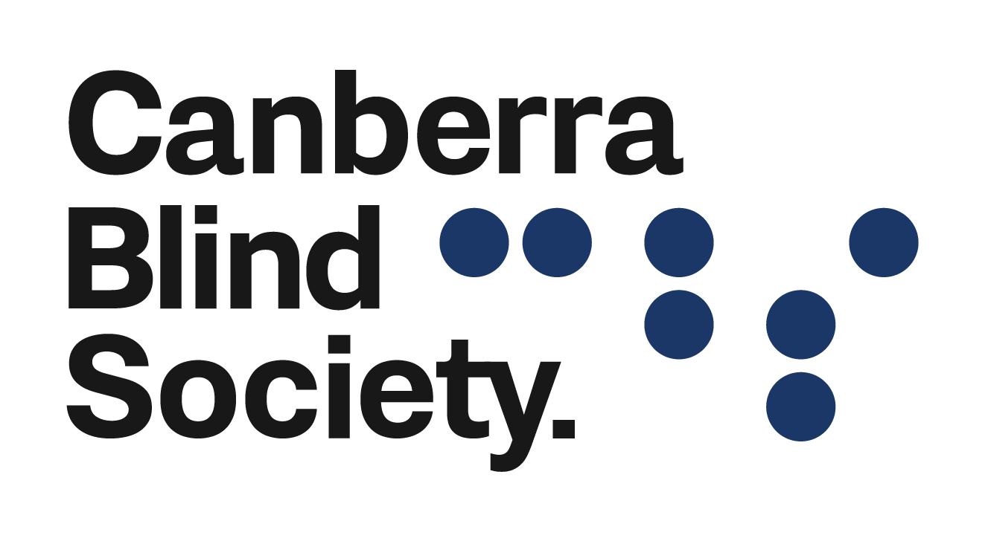

Notice Board

June 2021
2 | First Wednesday | 10:00 |  |  | Audio Book Club
3,10, 17, 24 | Thursdays |  | 10:00 | Braille Group
9, 23 | Second and Fourth Wednesday | 10:00 |  |  | Arts and Crafts
18 | Third Friday |  | 10:00 | Sense-Able Cooking
July 2021
7 | First Wednesday | 10:00 |  |  | Audio Book Club
1, 8, 15,  22, 29 | Thursday |  | 10:00 | Braille Group
14, 28 | Second and Fourth Wednesday | 10:00 |  |  | Arts and Crafts
16 | Third Friday | 10:00 |  |  | Sense-Able Cooking
August 2021
4 | First Wednesday | 10:00 |  |  | Audio Book Club
5, 12,  19, 26 | Thursday |  | 10:00 | Braille Group
11, 25 | Second and Fourth Wednesday | 10:00 |  |  | Arts and Crafts
20 | Third Friday | 10:00 |  |  | Sense-Able Cooking

From the President’s Chair – Peter Granleese
As usual, things have been rather hectic at CBS over the last month, so I almost missed an important annual event of particular significance to CBS. I refer to National Volunteering Week (NVW) which took place this year on Monday 17 to Sunday 30 May. This annual event celebrates the important contribution of the almost six million Australians who volunteer 600 million hours of their time to their local communities. As we pause for a moment to reflect on the contribution volunteers make, we are mindful of the role volunteers play in the day to day running of CBS and its peer support programs. Volunteers perform many functions at CBS, and it is true to say that without their assistance, we will not be able to provide the services we intend to provide.

CBS was founded in a Canberra living room in 1958 by concerned volunteers to provide Braille transcription services to children attending Canberra Schools and also provide support to older vision impaired people then living in Canberra. At that time, Canberra had a population of 57,000 and was little more than a large country town. Children who were blind or had low vision were forced to attend blind school in Sydney or Melbourne, with all the disruption to family that this caused. Older people who lost their sight later in life, were forced to rely on family for support or enter paid care.

From these small beginnings, CBS has grown into the organisation that it is today. Over the last 63 years, CBS has continued to grow as it adapted to the changing needs of the Canberra community.

CBS has gone through another major change with the loss of ongoing funding following the introduction of the NDIS. After a three-year relationship with The Royal Society of The Blind of South Australia, CBS found itself in the unhappy position of having no money and no staff to run the Society. For the next three years CBS was able to keep its doors open with the assistance of a small group of dedicated vision impaired volunteers. Happily, CBS has now received NDIS funding to employ an executive officer to coordinate services and also employ an outreach officer to run the outreach program who will commence with CBS from 1 July. As we look back on the 63 years of continuous service to the community, we acknowledge the role volunteers have played and thank them most sincerely for their hard work and dedication. If you would like to become a volunteer, we would like to hear from you. You can contact us by email at volunteers@canberrablindsociety.org.au or by telephone 6247 4580.

The Way I see It – Graham Downie
Perhaps the most difficult decision when waiting at a bus stop, knowing your transport was due five minutes ago, is whether to continue to wait with the hope the thing will arrive shortly, or to give up and call a taxi or ride share vehicle.
While not producing a bus on demand, there are several apps which can greatly help the weary traveller to know whether a scheduled service is operating and the extent to which it is running late, early or on time.
The ACT government’s NxtBus can be accessed online, nxtbus.act.gov.au or by text, 0432 131 710. Though this was promoted as providing real time information when launched some years ago, there remains deep suspicion, certainly by me, that information provided invariably reflects the timetable schedule and not the actual time a bus will arrive.
A great improvement on this is available by smart phone apps which really do show, not only when the next bus is expected to arrive at your stop, but where that bus is. This information is especially useful to people familiar with the particular route.
For people who are blind or vision impaired, at least two, and perhaps many more or these apps, are accessible on iPhone. These are Moovit and NextThere. These two are cited here because they both include Canberra’s public transport and can be used interstate.
The app I have come to use almost every time I travel is NextThere. I do not suggest it is better than Moovit, which comes highly recommended by some vision impaired colleagues. Put simply, I began with NextThere, found it suited my needs and stuck with it.
Both have versions at no charge. To date, I have had no reason to use the paid version. To use the app, simply open it by navigating on your phone, though generally I simply ask Siri to open it. Generally, it opens with a button to find nearby stops. Here there is a list of stops, beginning with the stops closest to your physical position. Simply tap the button for the desired stop, then slide a finger down the screen. This can be a bit fiddly, but mostly you will find information for departures from the chosen stop. By tapping on the service required, a PNG image of a bus pops up. Flick right from that image and the text will tell you where the bus is. People with sufficient vision can see the image on a map of the route.
Instead of tapping on ‘find nearby stops’, if you flick right, an edit field can be used to search for a stop. This is made much easier if you know the identification code for the stop. A dictation button allows easy input.
The system of identification codes seems quite random, often with successive numbers relating to stops many kilometres apart. The timetable boards at some shopping centre stops display the code with large, raised numbers and Braille. Otherwise, the easiest way to find a code for a particular stop is the link, nxtbus.act.gov.au. In the edit field, put in the route number, then arrow down the list of stops, each of which shows the relevant code. There is also a button which takes you to a table showing the next departures for that stop. Grateful thanks to Transport Canberra’s Barbara for this helpful information.
The easiest option when using the app around multiple stops such as interchanges is to find the code for the particular station. If this is not possible, the app has a section index, similar to that used in iPhone’s contacts. Tap twice then hold to bring up the index, then slide a finger down the alphabetical list to reach the required destination. Since transport authorities have made the audio information system too time consuming, the app is my preferred way of checking bus departures from interchanges.
Meanwhile, I heard recently of an app being developed in Sydney which would allow people to locate specific bus stops, then to receive information about bus arrivals. Further, and of help, particularly on busy roads where an approaching bus might not be heard or which are served by multiple routes, to press a ‘hail bus’ button. This would alert the relevant driver to stop for a passenger. The proposed app also allows for people to include their destination stop, which would also show on the driver’s screen. Though being developed with people who are blind, or vision impaired in mind, NSW transport authorities are apparently very interested in the app for general use. It is hoped ACT transport authorities will also be interested in this development.

Microwave conversion kits
CBS has conversion kits that will convert a non-talking microwave to a talking microwave. You can use a microwave that is less than 5 years old and has a keypad (not dials or push buttons). The conversion kits are available at CBS and we have an agreement with a company in Canberra to do the conversion. CBS purchased a cheap 20L microwave and had it converted, with the finished product now in the CBS kitchen for you to try. The conversion can work with microwaves of any size and so it allows you to have your preferred size to fit in your own kitchen area. It also allows you to use or purchase any brand of non-talking microwave and then have it converted to talking.

Tech Updates – How to lock Portrait Orientation on your iPhone or iPad
On an iPhone, when you tilt your device on its side, the screen follows and rotates to landscape orientation. Turning on portrait orientation locks the screen so that no matter which way your iPhone is turned, the screen will stay in place. Instead of your iPhone screen flipping between portrait and landscape view, you can use portrait orientation lock.
You can lock the screen orientation on your iPhone or later model of iPad quickly and easily in the Control Center. If you have an iPad Pro, iPad Mini 4, or iPad Air 2, or any of the later models, you will be able to lock your iPad screen using portrait orientation in the Control Center just like you do on the iPhone. To do this:
Open the Control Center. On iPhone X or later, swipe down from the top right side of your iPhone screen. If you have an iPhone SE (2nd gen) or an iPhone 8 or earlier, swipe up from the bottom of your screen (3 finger swipe up for VoiceOver users), to open the Control Center.
Select the Portrait Orientation Lock icon.
Your device’s orientation will now stay locked in portrait mode until you turn Portrait Orientation Lock off. It’s simple to unlock screen rotation on iPhone or iPad, just open Control Centre again and select the lock icon again. There is no option for locking your iPhone screen in landscape mode.

How to Turn on Lock Rotation on Your iPad (Air or Earlier)
If you have an older version on iPad, you can lock your screen on iPad using the side switch. This works for iPad Mini 1/2/3, iPad Air, iPad 2, iPad (3rd generation), and iPad (4th generation). When you have one of those models of iPad, you can set the side switch to lock and unlock your iPad’s screen orientation in Settings or you can use Control Centre. To do this:
- Open Settings.
- Select General.
- Select Lock Rotation under Use Side Switch To…
You can now use the side switch to lock your iPad in portrait or landscape mode.
If you prefer to use the side switch as a mute button, you can lock your iPad’s screen orientation by holding the iPad in either landscape or portrait orientation, swiping up to open Control Centre, and selecting the Orientation Lock icon.
https://coolblindtech.com/how-to-lock-portrait-orientation-on-your-iphone-or-ipad/

Music at Midday - Canberra Theatre Centre
The Canberra Blind Society is the featured charity at Canberra Theatre Centre’s Music At Midday concert on 8 June 2021. Due to Covid protocols the Canberra Theatre requires everyone to register before the performance date. Registration is free and entry is just a gold coin donation and you can enjoy The Royal Military College band playing their take on modern hits as well as some old favourites. Please share this, let’s get as many people there as possible! It's a lovely way to spend lunchtime, and even better it benefits a great cause.

National Gallery of Australia
Know My Name: Australia Women Artists 1900 to Now
June 6 11.00am – 12.00pm
A 60-minute exhibition tour of Know My Name: Australian Women Artists 1900 to Now for people who are blind or low vision.
Know My Name: Australian Women Artists 1900 to Now showcases art made by women. It brings together more than 300 works, drawn from the Gallery’s collection and other collections from across Australia. This exhibition is part of a series of ongoing initiatives by the National Gallery to increase the representation of artists who identify as women in its artistic program.
Price : Free, bookings essential
Venue : Know My Name exhibition (Level 1)

National Portrait Gallery - audio described programs
There is an upcoming Audio Described tour onsite with a staff member guiding people through the Australian Love Stories exhibition on Sunday 16 May. This might be of interest to some CBS members.
https://www.portrait.gov.au/calendar/love-stories-audio-described-tour/2210
The National Portrait Gallery is currently working on writing audio descriptions for our upcoming exhibition Australian Love Stories and these recordings will be available on their website and onsite for users sometime in April.

In the kitchen

Pizza bases [3]
INGREDIENTS
480 g bread flour (3 cups)
Pinch of salt
270 ml warm water
1 tablespoon oil
1 teaspoon sugar
1 7g sachet of dry yeast

METHOD
In small bowl add sugar, warm water and yeast and leave till bubbles form approx. 5 mins
In a large bowl add bread flour, oil and salt.
Make a well in the dry ingredients and slowly stir wet ingredients and mix well till a dough ball forms.
Knead dough till smooth and stretchy approx. 7 mins. Divide into 3 balls.
Place dough balls in an oiled container for 2 hours minimum or in the fridge overnight. After proofing, shape the dough ball by rolling or stretching into a circle.
Place pizza base onto a tray that is oiled or floured.
Add tomato-based sauce or BBQ sauce and toppings of your choice.
Let rise for 10 minutes
Bake in a hot oven for 20-25 mins for a large pizza, or until done.

Braille Group – Sharon Sobey
The Braille Group meets at the Griffin Centre on Thursdays from 10:00 in the CBS office. Enquiries from new or existing members can contact Sharon Sobey on 0419 263 413.

Book Group
We have seats at the table for those who like good stories, a variety of issues to discuss, and making new friends. We meet on Wednesday 2nd June and every first Wednesday of the month at 10:00. Our next book is “We Are All Completely Beside Ourselves” by Karen Fowler. Please connect with Bob James on 6296 2644 or the CBS Office if you are interested in finding out how to join. Our July book will be “The Woman in the Window” a thriller.

Arts and Crafts Group
The Arts and Crafts group meets every second and fourth Wednesday of each month. The next meeting will be on 9th June commencing at 10am. If you would like to join the group and have not already notified us please contact the office to add your name to the circulation list.

Thanks to our Sponsors
Canberra Blind Society thanks our sponsors for supporting us.

Southern Cross Club Community Rewards Program
Members of the Southern Cross Club can help us raise funds by taking part in the Southern Cross Club’s Community Rewards program

